**In the following lab you will develop a SOAP service using JAX-WS and an XML-RPC service using the Apache XML-RPC framework**

1. Do the following Calculator tutorial (<http://netbeans.org/kb/docs/websvc/jax-ws.html> Use the Java SE client (Client 1) rather than the web client (Client 2) shown in the tutorial. Note – it works with Netbeans 8.2 (and glassfish 4.1.1) (maybe not with later versions)
2. Do the tutorial to consuming a Web Service at <https://netbeans.org/kb/docs/websvc/client.html> . Use the live service at <https://graphical.weather.gov/xml/SOAP_server/ndfdXMLserver.php> rather than the spell checking service here. You can view more about the service using SOAPUI before using the services – maybe then use the LatLonListCityNames method – it works without any parameters (see link below for SOAPUI)
3. Develop a Hello World SOAP web service starting from a WSDL file in a top down fashion (Use the Hello World wsdl file given)
4. Develop a SOAP web service to reverse a word in a bottom up fashion as demonstrated in question 1.
5. Develop an XML-RPC application as described at <https://www.tutorialspoint.com/xml-rpc/xml_rpc_examples.htm>

**Note on Frameworks**

Java supports building web services with the following frameworks:

* [JAX-WS](http://en.wikipedia.org/wiki/JAX-WS) : The **Java API for XML Web Services** is a [Java programming language](http://en.wikipedia.org/wiki/Java_(programming_language)) [API](http://en.wikipedia.org/wiki/Application_programming_interface) for creating [web services](http://en.wikipedia.org/wiki/Web_service), particularly SOAP services.
* JAX-RS (for REST services – see later labs)

JAX-WS uses [annotations](http://en.wikipedia.org/wiki/Java_annotation) to simplify the development and deployment of web service clients and endpoints.

Apache CXF is an [open-source](http://en.wikipedia.org/wiki/Open_source_software), fully featured [Web services](http://en.wikipedia.org/wiki/Web_services) framework. <https://cxf.apache.org/>

**Optional**

Investigate how to develop web services in Visual Studio. Can you develop top down and bottom up in Visual Studio?

**Testing SOAP APIs**

<https://www.soapui.org/>

* + Download SOAPUI
  + Create a new project and then add WSDL to the project

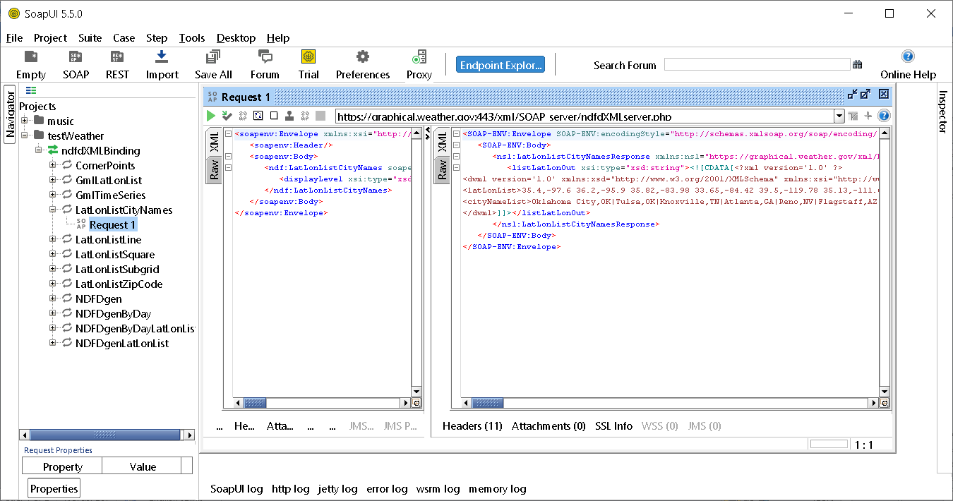

* + Add WSDL for US weather service at <https://graphical.weather.gov/xml/SOAP_server/ndfdXMLserver.php>
  + Send a SOAP request to one of the SOAP end point – Above I am sending a request to LatLonListCityNames –no parameters needed.
  + If you use the NDFDGen method use the data for New York in the Request to get a weather forcast for New York right now)

<latitude xsi:type="xsd:decimal">40.730610</latitude>

<longitude xsi:type="xsd:decimal">-73.935242</longitude>

<product xsi:type="xsd:string">glance</product>

<startTime xsi:type="xsd:dateTime"></startTime>

<endTime xsi:type="xsd:dateTime"></endTime>

<Unit xsi:type="xsd:string"></Unit>

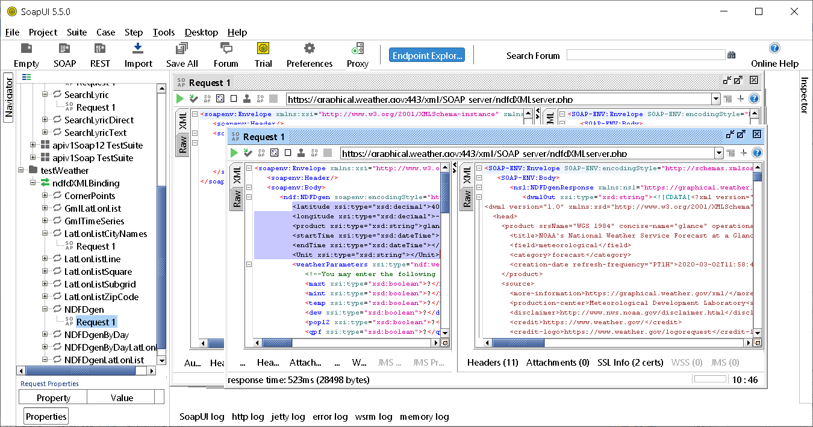

* + Can you can generate and test mock SOAP APIs etc in SOAPUI and even turn SOAP APIs into REST APIs

**APIs are Dead?**

<https://dzone.com/articles/api-is-dead-long-live-the-apis>